WEEK 6: ARCHITECTURAL DESIGN

Lab 6 — Choosing and Documenting Architecture
Selected Architectural Pattern MVC:

The Women's University Complaint Reporting System will use the Model-View-Controller (MVC) architectural pattern. MVC separates the application into three components: Model, View, and Controller.

The View displays the user interface, including the login page, complaint submission form, and administrator dashboard. The Controller processes user requests, validates information, and coordinates system operations. The Model manages the system's data and communicates with the MySQL database.

This architecture will help organize the application and make it easier to maintain, test, and extend in the future
Major modules are:
1. User Interface: Allows students and administrators to interact with the system.
2. Authentication Module: Handles login and verifies user permissions.
3. Complaint Management Module: Supports submitting, viewing, and managing complaints.
4. Category Management Module: Organizes complaints into categories.
5. Status Tracking Module: Allows students to check complaint progress.
6. Notification Module: Provides confirmation messages and complaint status updates.
7. Database Module: Stores and retrieves information using MySQL

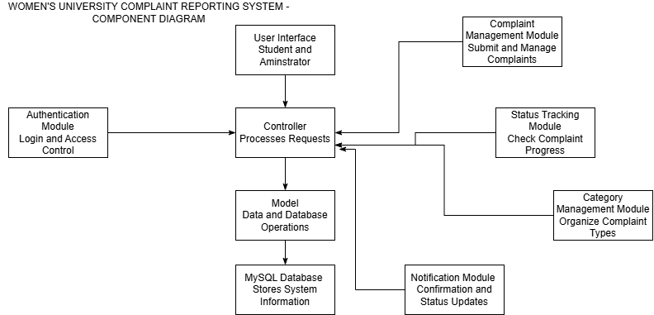

JUSTIFICATION OF MVC
MVC was selected because
1. Maintainability: Separating the user interface, processing logic, and data management makes the application easier to modify.
2. Security: The Controller can validate information and enforce access permissions. Students should only access their own complaints, while authorized administrators can manage complaints.
3. Scalability: The system can be expanded with additional features, such as email notifications and complaint reports.
4. Reusability: Components can be reused across different parts of the application.
5. Testability: Individual components and application functions can be tested to identify errors.

